**NAME: SYED ALI ASAD BUKHARI**

**ROLL.NO: BCS233001**

**ASSIGNMENT.3**

**Q#1: Create a class Student with data members: name, roll_number, and marks. • Implement member functions to input and display student data. • Create a program to: o Create a file named students.txt. o Write data of 5 students to the file using ofstream. o Read the data from the file and display it using ifstream. o Modify the marks of a specific student using fstream.**

**INPUT:**

#include <iostream>

#include <fstream>

#include <string>

using namespace std;

class Student {

public:

string name;

int roll_number;

int marks;

void input() {

cout << "Enter name: ";

cin.ignore();

getline(cin, name);

cout << "Enter roll number: ";

cin >> roll_number;

cout << "Enter marks: ";

cin >> marks;

}

void display() const {

cout << "Name: " << name << endl;

cout << "Roll Number: " << roll_number << endl;

cout << "Marks: " << marks << endl;

}

};

int main() {

Student students[5];

for (int i = 0; i < 5; i++) {

cout << "Enter data for student " << i + 1 << endl;

students[i].input();

}

ofstream file("students.txt");

if (file.is_open()) {

for (int i = 0; i < 5; i++) {

file << students[i].name << endl;

file << students[i].roll_number << endl;

file << students[i].marks << endl;

}

file.close();

cout << "Data written to file successfully." << endl;

}

else {

cout << "Unable to open file for writing." << endl;

return 1;

}

ifstream fileRead("students.txt");

if (fileRead.is_open()) {

string name;

int roll_number, marks;

for (int i = 0; i < 5; i++) {

getline(fileRead, name);

fileRead >> roll_number >> marks;

fileRead.ignore(); // Ignore the newline after marks

cout << "Student " << i + 1 << ":" << endl;

cout << "Name: " << name << endl;

cout << "Roll Number: " << roll_number << endl;

cout << "Marks: " << marks << endl;

cout << endl;

}

fileRead.close();

cout << "Data read from file successfully." << endl;

}

else {

cout << "Unable to open file for reading." << endl;

return 1;

}

int roll_number_to_modify;

cout << "Enter roll number of student to modify marks: ";

cin >> roll_number_to_modify;

Student modifiedStudents[5];

ifstream inFile("students.txt");

if (inFile.is_open()) {

for (int i = 0; i < 5; i++) {

getline(inFile, modifiedStudents[i].name);

inFile >> modifiedStudents[i].roll_number >> modifiedStudents[i].marks;

inFile.ignore();

}

inFile.close();

bool found = false;

for (int i = 0; i < 5; i++) {

if (modifiedStudents[i].roll_number == roll_number_to_modify) {

cout << "Enter new marks for " << modifiedStudents[i].name << ": ";

cin >> modifiedStudents[i].marks;

found = true;

break;

}

}

if (!found) {

cout << "Roll number not found." << endl;

}

else {

ofstream outFile("students.txt");

if (outFile.is_open()) {

for (int i = 0; i < 5; i++) {

outFile << modifiedStudents[i].name << endl;

outFile << modifiedStudents[i].roll_number << endl;

outFile << modifiedStudents[i].marks << endl;

}

outFile.close();

cout << "Marks modified successfully." << endl;

}

else {

cout << "Unable to open file for writing." << endl;

}

}

}

else {

cout << "Unable to open file for reading." << endl;

}

return 0;

}

**OUTPUT:**

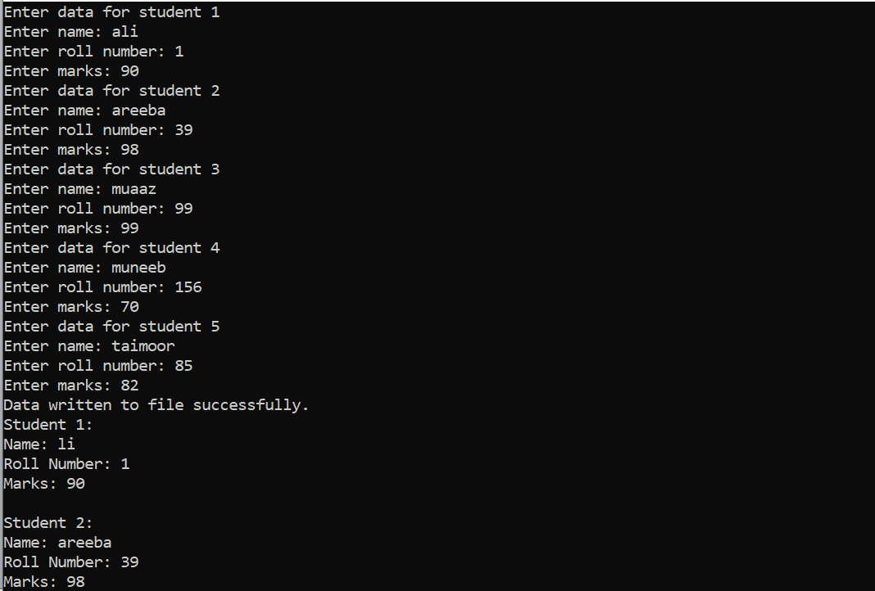

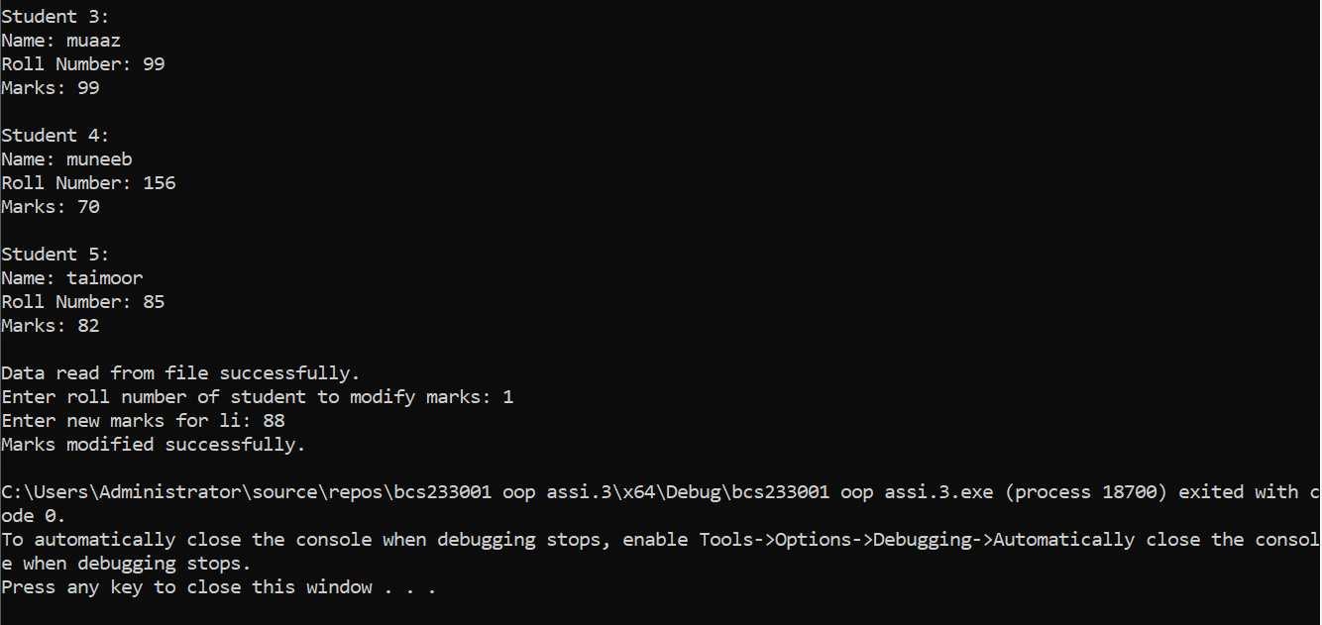

**Q#2:PART.A: Create a base class Shape with data member color and member functions to set and get color. • Create a derived class Rectangle inheriting Shape with data members length and breadth. • Implement member functions to calculate area and perimeter of the rectangle. • Demonstrate constructor chaining in both base and derived classes.**

**INPUT** #include <iostream>

#include <string>

using namespace std;

class Shape {

protected:

string color;

public:

Shape(const string& c = "black") : color(c) {}

void setColor(const string& c) {

color = c;

}

string getColor() const {

return color;

}

};

class Rectangle : public Shape {

private:

int length;

int breadth;

public:

Rectangle(int l, int b, const string& c = "black")

: Shape(c), length(l), breadth(b) {}

int getLength() const {

return length;

}

int getBreadth() const {

return breadth;

}

int area() const {

return length * breadth;

}

int perimeter() const {

return 2 * (length + breadth);

}

};

int main() {

Rectangle rect(7, 5, "red");

cout << "Color: " << rect.getColor() << endl;

cout << "Length: " << rect.getLength() << endl;

cout << "Breadth: " << rect.getBreadth() << endl;

cout << "Area: " << rect.area() << endl;

cout << "Perimeter: " << rect.perimeter() << endl;

return 0;

}

**OUTPUT:**

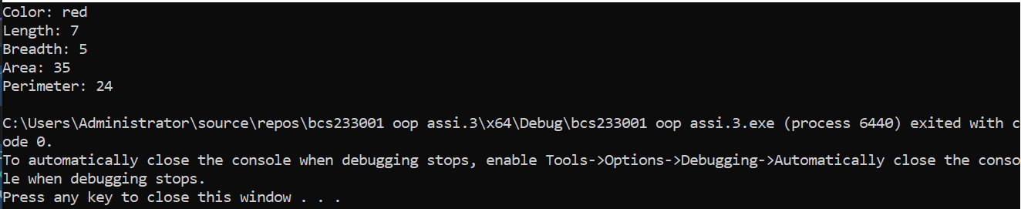

**Part B:**

**Create a base class Animal with data member name. • Create a derived class Mammal inheriting Animal with data member numberOfLegs. • Create a derived class Dog inheriting Mammal with member functions to bark. • Demonstrate object creation and access to members of all classes**.

**Input:**

#include <iostream>

#include <string>

using namespace std;

class Animal {

protected:

string name;

public:

Animal(const string& n) : name(n) {}

string getName() const {

return name;

}

};

class Mammal : public Animal {

protected:

int numberOfLegs;

public:

Mammal(const string& n, int legs) : Animal(n), numberOfLegs(legs) {}

int getNumberOfLegs() const {

return numberOfLegs;

}

};

class Dog : public Mammal {

public:

Dog(const string& n, int legs) : Mammal(n, legs) {}

void bark() const {

cout << "Woof! " << getName() << " is barking!" << endl;

}

};

int main() {

Dog myDog("german shepherd", 4);

cout << "Name:cheeck daba dum dum " << myDog.getName() << endl;

cout << "Number of Legs: " << myDog.getNumberOfLegs() << endl;

myDog.bark();

return 0;

}

**Output:**

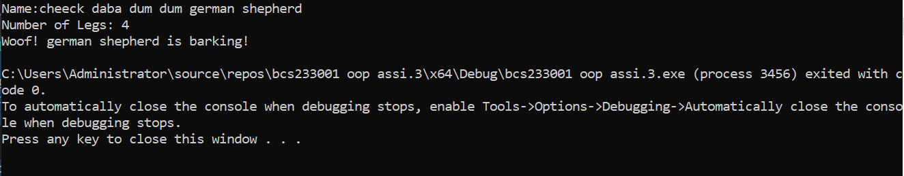

**Part C:**

**Create a base class Person with data members name and address. • Create another base class Employee with data members employeeID and salary. • Create a derived class Teacher inheriting both Person and Employee with additional data member subject. • Demonstrate object creation and access to members of all classes. • Discuss the ambiguity problem in multiple inheritance and how to resolve it.**

**Input:** #include <iostream>

#include <string>

using namespace std;

class Person {

protected:

string name;

string address;

public:

Person(const string& n, const string& a) : name(n), address(a) {}

string getName() const {

return name;

}

string getAddress() const {

return address;

}

};

class Employee {

protected:

int employeeID;

double salary;

public:

Employee(int id, double s) : employeeID(id), salary(s) {}

int getEmployeeID() const {

return employeeID;

}

double getSalary() const {

return salary;

}

};

class Teacher : public Person, public Employee {

private:

string subject;

public:

Teacher(const string& n, const string& a, int id, double s, const string& sub)

: Person(n, a), Employee(id, s), subject(sub) {}

string getSubject() const {

return subject;

}

};

int main() {

Teacher myTeacher("mam ayesha", "gulshanabad", 3452, 50000.0, "Math");

cout << "Name: " << myTeacher.getName() << endl;

cout << "Address: " << myTeacher.getAddress() << endl;

cout << "Employee ID: " << myTeacher.getEmployeeID() << endl;

cout << "Salary: " << myTeacher.getSalary() << endl;

cout << "Subject: " << myTeacher.getSubject() << endl;

return 0;

}

**Output:**

